Ladoire's Black Widow Hits the Jackpot in Las Vegas!
The sultry Black Widow has struck yet again. Lionel Ladoire’s deconstructionist vision of a the GMT watch first seduced the eponymous Mr Green, which launched the exciting new Black Widow Collection at the beginning of this year.
And more recently a distinguished panel of judges assembled by Couture Time also fell victim to the charms of the Black Widow, awarding it the prize for best "Watch Architecture". The inaugural presentation ceremony took in the fabulous Encore Ballroom at the Wynn Hotel/Casino in Las Vegas.

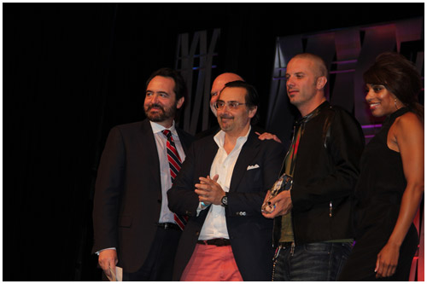

With its distinctive asymmetrical case, open-dial architecture, discrete time indications and bespoke strap and buckle, it’s not hard to see why Black Widow snared the award, which took into account excellence in case, dial and/or strap design.

Pervaded by a dark, angst-ridden ambience, Mr Green is the first chapter in this murderous Black Widow saga in which the timepiece, the object of every desire, arouses extreme reactions and engenders irreparable damage. The deconstruction of time favored by Lionel Ladoire is conveyed through a dial with green, red and white accents that, along with the choice of materials and finishes, are the key signature features of the four models in the Black Widow collection (only two of which, Mr Green and Mr Race, have been launched to date).

The dial structure, open-worked to reveal the movement, is multilayered and delineates three regulator-type offset Hours, Minutes and Seconds zones with patented display complication mounted on ceramic micro ball bearings. Moreover, the watches in the Black Widow collections also feature a GMT function with a central hand adjusted via a fast action pusher at 2 o’clock.
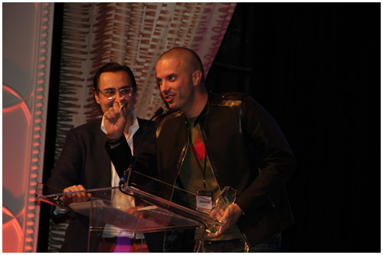

Presented as part of the Couture Design Awards, the prize-giving ceremony on the 4th of June in Las Vegas was the culmination of the Couture Time exhibition and is the only contest of its kind in the USA. Jurors included John Reardon, head of the Watch and Clock

Department at Sotheby’s in New York; Keith Strandberg, International Editor at Watch Journal; veteran watch journalist Roberta Naas; watch collector and TimeZone.com forum moderator Sam Yukon; and celebrity chef and watch collector Nick Stellino.

Watch Journal publisher Glen Bowen hailed the importance of the unique, all-new American awards program, saying: “Watch Journal and Couture created the Couture Time Jury Prize to highlight the achievements of today’s top watchmakers and draw attention to the amazing work they are doing. The results of the inaugural competition demonstrate the jury’s appreciation for the extraordinary creativity of young, Swiss watch brands.”

Couture Time by Watch Journal is a program of Couture, the leading destination for the luxury jewelry trade during Las Vegas Market Week. Couture Time presents the world’s top luxury watch brands to America’s top-tier jewelry retailers. Couture Time takes place each year in early June at the Wynn Las Vegas.

For more information about Mr Green or any of the other models in the Ladoire collection, please visit www.ladoire.ch, join us on Facebook, or follow us on Twitter. Ladoire Rocks your Time!



